**FINAL PROJECT REPORT**

**COSC 729**

**Project Title: Shooty Shoot**

**(Tunde Ayodele & Tolulope Oshuntoye)**

**Project** **Title: Shooty Shoot**

**( Tunde Ayodele and Tolulope Oshuntoye)**

**COSC 729 Spring 2022**

**GOALS AND OBJECTIVES**

The name of the project is shooty shoot, this is a first-person shooter game, the game shows concepts learnt in class can be incorporated to produce a game. They include: model designs from sketch up to first person controller, health bar, weapon system, level upgrade, importing audio as well as scripting and adding interactivity.

The game has levels, Enemy systems as well as a weapon system, the player of the game can pick up weapons as he progresses in the game, the health system is also for the player to upgrade his health as he loses health in the course of battle.

The Environment for the game is simulation of a mall environment. The objective of this project is to clearly show the concepts learnt in class:

* Modeling
* First person controller concept
* Health system
* Interactivity
* UI system
* Model importing

**MODELING**

The models used in the game were imported from Google SketchUp, which is a tool for modeling 3d Environments. This Environment is a simple simulation of a mall. The application the First person shooter can move around the Environment, as the first person comes to a few meters to the enemy, there is a trigger which causes the enemy to start running towards the shooter, the shooter will have to shoot certain number of bullets before the enemy is killed.

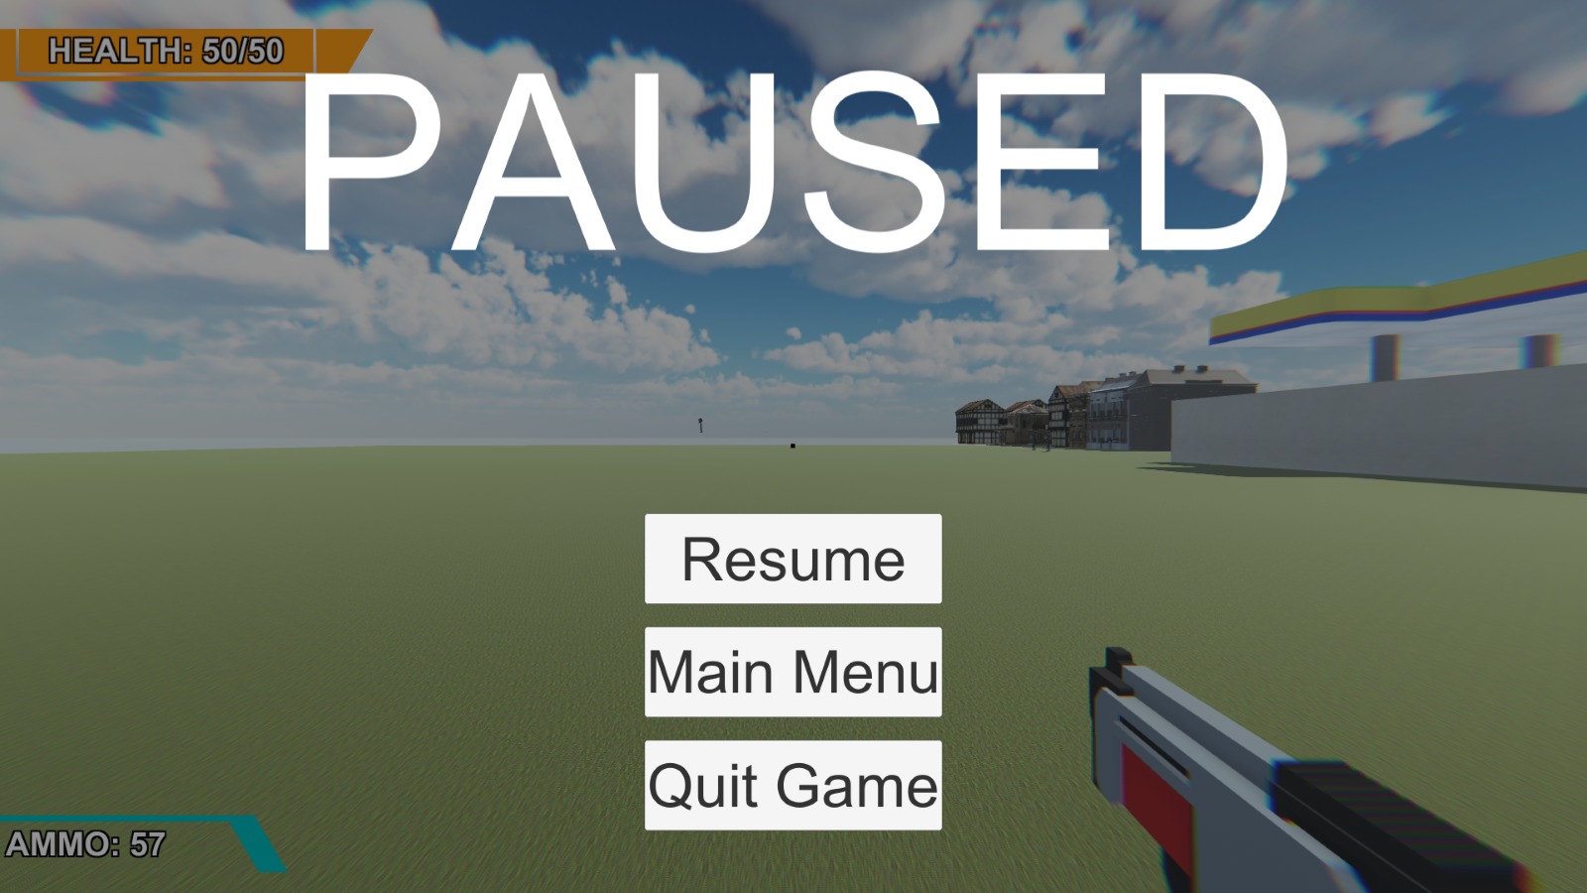

FIg 1. Showing the the user interface

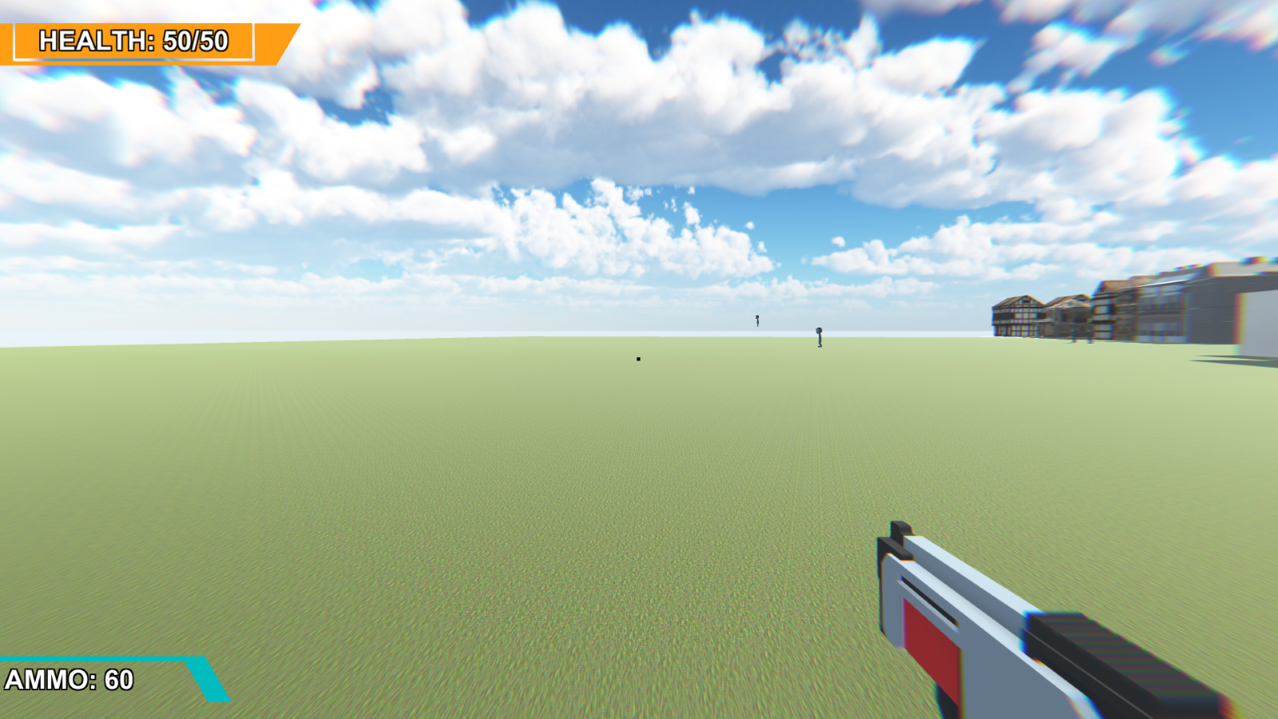

Fig 1.1 showing the Skybox, and back side of the building

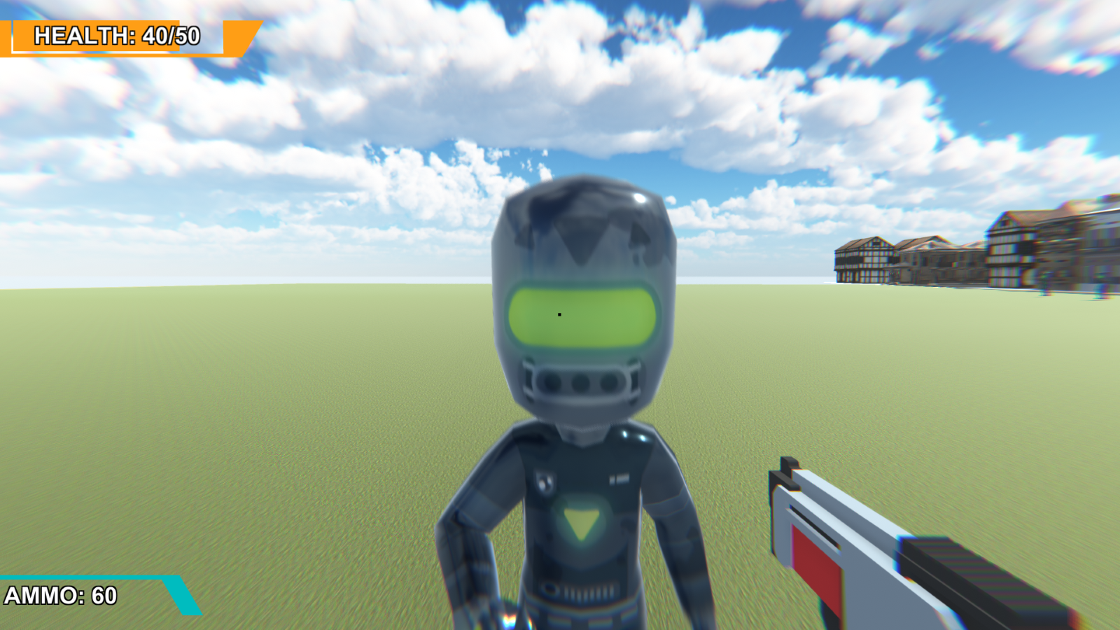

Fig 1.3 The Enemy

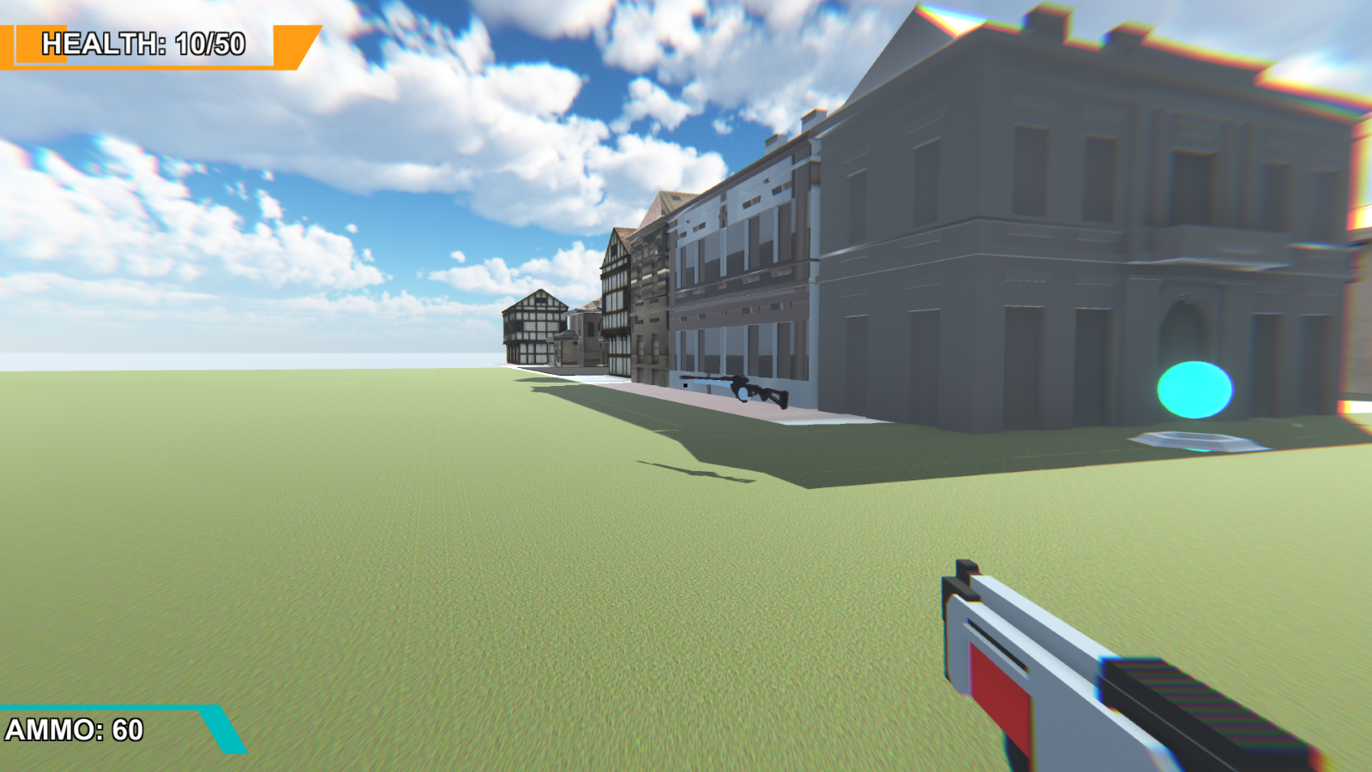

Fih 1.4 Acloser View of the building

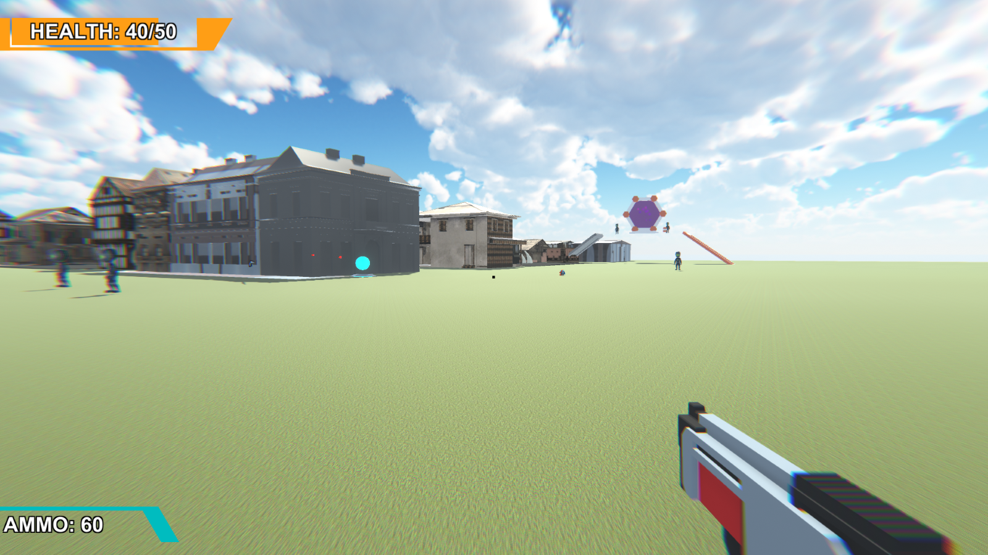

Fig 1.5 The Ammo and health system



Fig 1.6



Fig 1.7

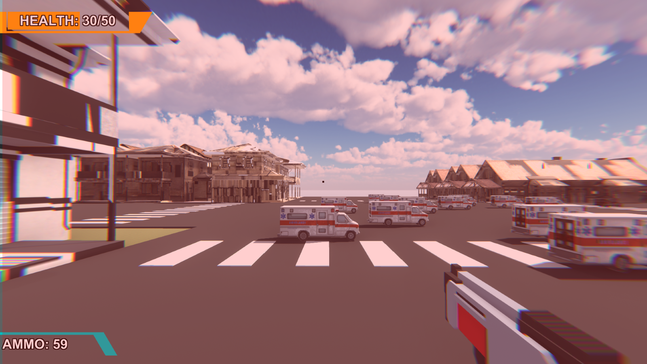

Fig 1.8 showing the Ambulances

**Sounds**

There is an implementation of Audio which was a concept learnt in class. This is heard during the course of the game, also the sound of gun shots

**Animation**

Animations were also implemented in the game, there is a floating gun, and moving Avatars.

**Sensor**

There is a simple simulation of a sensor system, when the shooter gets a certain distance close to the enemy, the enemy senses the presence of the shooter and invariably moves towards the shooter.

**Unity Functionality**

There is a health system which indicates the health level of the first-person shooter, as the total health is 50%, as it gets to 0% the first-person shooter dies.

**Implementation Plan**

The models were built by Tolulope Oshuntoye using google SketchUp, while the c# script was implemented by Tunde Ayodele

**Implementation Plan**

The models were built by Tolulope Oshuntoye using google SketchUp, while the c# script was implemented by Tunde Ayodele

**Usage**

The entire built can be used to shot simple animations as well as show introduction to concepts in virtual reality and it apps

**Challenges**

One of the problems encountered was getting the right Environment to simulate the mall

**Shortcomings**

The game has some shortcoming which I believe can be overcome, the avatar can be improved, also the environment. Furthermore, the Ambulance system can also be improved upon

**Recommendations**

Adding An Avatar as the first person shooter, also creating multiple scenes

**SOFTWARE TOOLS**

Unity Game Engine

Google Sketchup

Unity Asset Store

Windows 11.

**REFERENCES:**

<https://sharadonly.github.io/3DGalleryAssets.zip>

<https://sharadonly.github.io/vrlab/Projects2021.html>